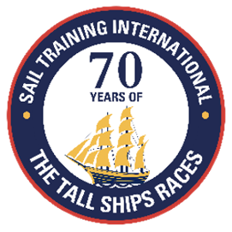
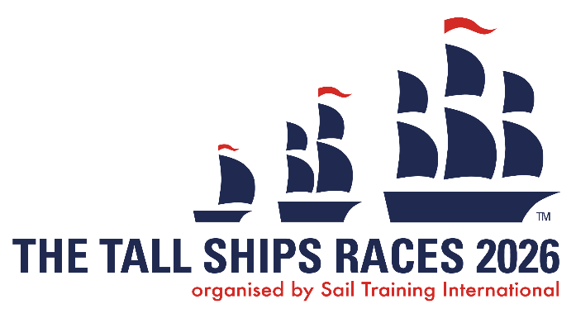

SAIL TRAINING INTERNATIONAL EDITORS’ NOTES

About Sail Training International
Sail Training International is, a registered international charity and not-for-profit organization which has worldwide membership and activities. Its purpose is the development and education of young people through the Sail Training experience, regardless of nationality, culture, religion, gender or social background.
Sail Training International has been organising The Tall Ship Races every year since 1956, as well as other international Tall Ship sailing events. 2026 marks 70 years of The Tall Ships Races; empowering young people through the experience of sail training.
Sail Training International’s members are 26 national Sail Training organisations around the world.
The organisation was nominated for the Nobel Peace Prize 2007 for its work in promoting international understanding and friendship.
Every year, we make it possible for thousands of young people from all over the world, to benefit from a sail training experience and help those who need it through our bursary schemes.
What is Sail Training?
Sail Training is an adventure activity, which includes far more than sailing instruction. Participants are required to confront demanding challenges, both physical and emotional. It is an activity that inspires self-confidence and personal responsibility.
It promotes an acceptance of others, whatever their social or cultural backgrounds, and develops a willingness to take controlled risks. Those who experience a sail training voyage find it a positive life-changing experience and every year we are humbled by the heartfelt testimonials we receive from participants.

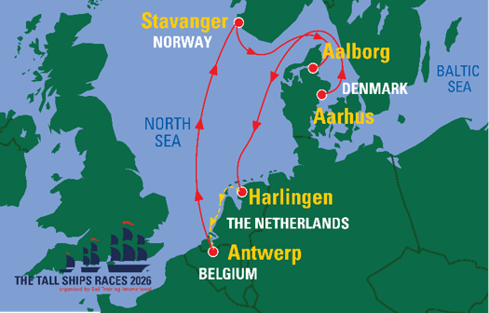

The Tall Ships Races 2026 route map

For more information, please contact Sail Training International:
Tel: +44 (0) 7824777781
Email: sam.leonard@sailtraininginternational.org
https://sailtraininginternational.org/sailtraining/

Social media links:



