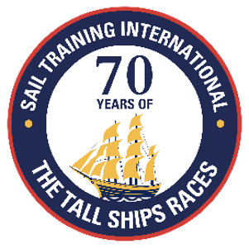
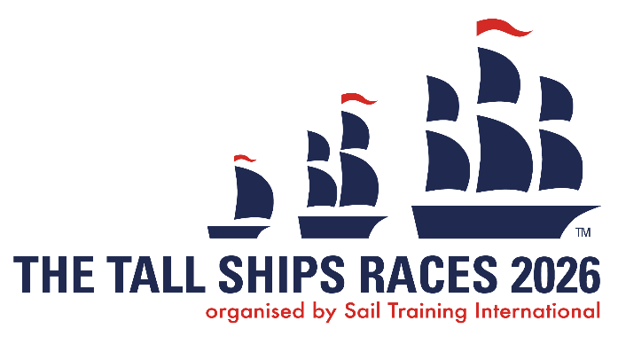

KEY MESSAGES:
SAIL TRAINING INTERNATIONAL & THE TALL SHIPS RACES AND REGATTAS

Youth Focused Sail Training
- Sail Training international (STI) is the organiser of The Tall Ships Races and is globally recognised as the voice of sail training.
- 2026 marks a huge milestone for Sail Training International, as they celebrate 70 years of The Tall Ships Races.
- Sail Training International is a non-political and a not-for-profit international charity with 26 member nations, representing a network of national sail training organisations.
- STI endeavour to promote and support the highest standards of sail training and youth work.
- The Tall Ships Races are open to everyone, and no experience is necessary.
- The Tall Ships Races offer a unique opportunity to experience exciting racing between vessels of different sizes
- Every year, Sail Training International offers bursaries to young people to enable them to take part in a sail training voyage (information available on our website)
- Participating in a Tall Ships Races or any other sail training voyage, inspires personal development, and helps young people discover hidden talents, develop self-confidence and learn new life skills. It also helps making new friends from all over the world and to develop a better understanding of different cultures and nations.
- The Youth Council, with representatives from all member nations, provides the organisation with the voice of young people and helps the organisation remain relevant and to continue to appeal to young people.
Sail Training International’s core values are:
- To create opportunities for self-development for young people,
regardless of their nationality, gender, social, cultural and religious background.
- To foster international friendship and understanding between all nations
- To encourage the protection of the environment and of our oceans
HOST PORT KEY MESSAGES
The Tall Ships Races is Europe’s largest free family festival.
Event Tourism: The Tall Ships Races attracts millions of international visitors every year, who come to see the ships, crews and trainees and experience the festival atmosphere of the races.
International Festival of Youth: The whole event is organised to support and help develop young people’s lives, promote international friendship and bring together ships from around the world.
Support for and Involvement in Sail Training for Young People: Inspires personal development and life-changing experiences for their young trainees and is open to all (no experience necessary), irrespective of social or cultural background. A requirement for participating vessels is that 50% of their crew must be aged between 15 and 25 years old.
Civic Showcase: Hosting The tall Ships Races drives tourism, increases local community engagement, has a strong economic impact on the city and drives future investment.
WHAT IS SAIL TRAINING?
Sail Training is an adventure activity, which includes far more than sailing instruction. Participants are required to confront demanding challenges, both physical and emotional. It is an activity that inspires self-confidence and personal responsibility.
It promotes an acceptance of others, whatever their social or cultural backgrounds, and develops a willingness to take controlled risks. Those who experience a sail training voyage, consistently find it a positive, life-changing experience and every year we are humbled by the heartfelt testimonials we receive from participants.
ABOUT THE EVENT: THE TALL SHIPS RACES 2026
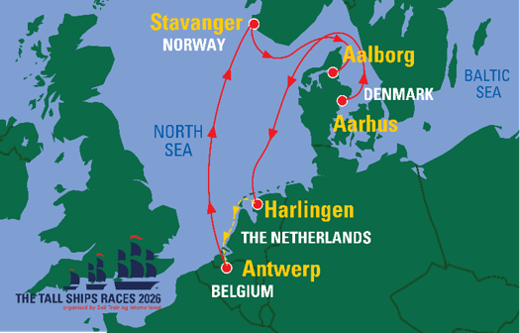
The Tall Ships Races 2026 is set to return to northern Europe and Sail Training International is delighted to be welcoming back long-term friends of the series, all of whom enjoy a rich history of hosting The Tall Ships Races. Between them, the ports of Aarhus, Harlingen, Antwerp, Stavanger and Aalborg have hosted over 20 editions of The Tall Ships Races. With this rich and storied legacy, we are confident they will all once again welcome the Tall Ships fleet with a spirit of adventure, and a commitment to our core values of youth development, and international friendship and understanding.
AARHUS, Denmark (24-27 June)
Aarhus is Denmark’s second-largest city and can trace its maritime history back to the days of the Vikings. It boasts a number of cultural attractions, including historic architecture and museums, which entertained visitors and crews alike during The Tall Ships Races’ last visit in 2019.
HARLINGEN, The Netherlands (3-6 July)
Harlingen is one of the oldest seaports in the Netherlands, and it’s the gateway to northern Holland from the North Sea. The city has a history that stretches back a thousand years, and this is reflected in some of the beautiful architecture on show.
ANTWERP, Belgium (11-14 July)
Located in the heart of Europe, Antwerp is a pocket-sized metropolis and Europe’s second-largest port. The Belgian city boasts some impressive and dramatic architecture, which provided a truly stunning environment for the 850,000 visitors who flocked to see The Tall Ships Races 2022.
STAVANGER, Norway (22 July - 25 July)
Stavanger is located on the south-western coast of Norway and last hosted The Tall Ships Races in 2018. The city waterfront comes alive throughout the summer, offering an enviable combination of small-town charm and metropolitan liveliness.
AALBORG, Denmark (30 July-2 August)
Aalborg is situated in the North of Jutland, Denmark, and has grown from an industrial hub into a vibrant, modern city. The recently updated waterfront areas are a focal point of the city and provided the ideal setting for the fleet during their last visit in 2022. Having hosted the event six times, it is thanks to Aalborg’s commitment to The Tall Ships Races that it has been awarded as one of Sail Training International’s Anchor Ports and will see The Tall Ships Races return to the city every four years.
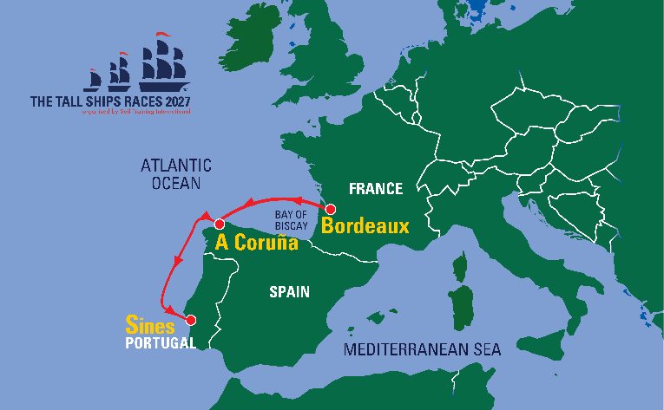
Event Preview: The Tall Ships Races 2027
For the 2027 race series, Sail Training International is excited to be welcoming back A Coruña as one of our most experienced host ports, alongside Bordeaux and Sines, who, having previously hosted Tall Ships Regattas in 2027, will be first time hosts of The Tall Ships Races. Each of the host cities will bring their own particular magic and national flavour to their in-port events and we are in no doubt, that the fleet and their crews will be warmly welcomed and looked after. As a charity, we are thrilled that Bordeaux, A Coruña and Sines continue to be aligned with our core values of youth development, and international friendship and understanding and we look forward to working with them to deliver The Tall Ships Races in 2027.
ABOUT THE HOST PORTS:
BORDEAUX (8-11 JuLY)
Bordeaux is the first port of The tall Ships Races 2027. The city is located on a bend of the Garonne River, around 500 km south-west of Paris. Bordeaux lies close to the Atlantic coastline, in the north of the Aquitaine region. Bordeaux boasts richly preserved historical architecture, pristine pedestrianised boulevards, tramways, and reclaimed industrial docks. In 2007, half the city (18 sq km) was listed as a UNESCO World Heritage site – the largest urban area to receive this accolade.
A CORUñA (16-19 July)
Located in northern Spain, A Coruña is a busy, bustling port. It’s located on a promontory in the entrance of an estuary in a large gulf on the Atlantic Ocean. It’s the richest region and economic engine of Galicia – an autonomous community in north-west Spain.
sINES (29 july-1 AUGUST)
The second port on the Races will be in Sines, a Portuguese Port City, located in the Setúbal disrtrict. With its beautiful scenery and cove beaches, Sines becomes a popular desitnation to visit during the summer, boasting for a busy race period.

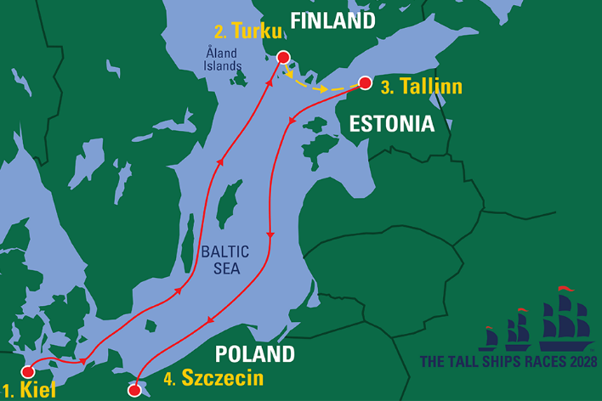
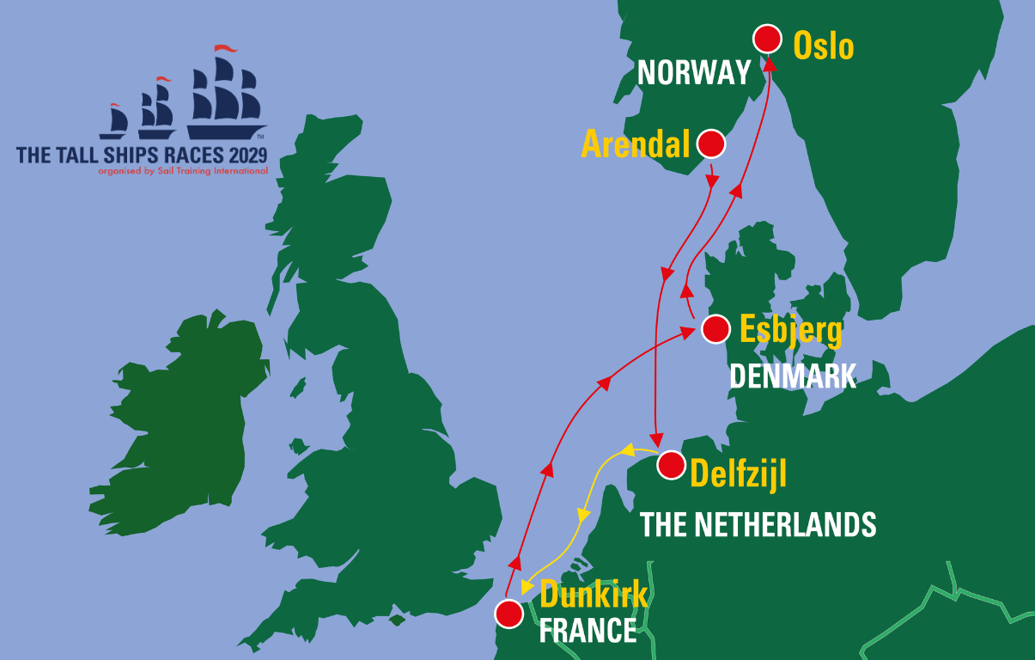
Future Tall Ships Races
TSR 2028 TSR 2029

For more information, please contact Sail Training International:
Tel: +44 (0) 23 9258 6367
Email: sam.leonard@sailtraininginternational.org
https://sailtraininginternational.org/sailtraining/
Social media links:


